
Company
Logotype

Cone Beam Computed Tomography- Report



Porur Dental X-rays & CBCT

Patient Name : Mrs. Ushadevi | Date of Report : 24.04.2024
Age/ Gender : 51 years/ Female | Region of Interest : CBCT Full Skull
Referring doctor: Dr. B. Naveen Kumar | Indication : Implant assessment
Clinical Notes: Nil
PATIENT INFORMATION

CBCT- Full skull provided
CBCT – IMAGE DETAILS

RADIOGRAPHIC INTERPRETATION

- Presence of hyperdense screw like structures (dental implant) in relation to 13, 14, 15, 17, 23, 24, 25, 27, 28, 31, 33, 34, 36, 42, 43, 45, 46 regions.
- The alveolar bone in relation to the placed implants are present with normal trabecular pattern.
- The implants in relation to 17 and 27 regions are positioned involving the floor of the right and left maxillary sinus.
- The implant in relation to 36 region is present at a distance of 2.4 mm from the inferior alveolar nerve canal.
- The implant in relation to 45 region is present at a distance of 3.4 mm from the inferior alveolar nerve canal.
- The implant in relation to 46 region is present at a distance of 4.6 mm from the inferior alveolar nerve canal.
- The right maxillary sinus is present with partial hyperdense opacification.

RADIOGRAPHIC IMPRESSION

- Dental implants in relation to 13, 14, 15, 17, 23, 24, 25, 27, 28, 31, 33, 34, 36, 42, 43, 45, 46 regions.
- Right maxillary sinusitis.

Kindly correlate with clinical findings


IMAGES FOR REFERENCE

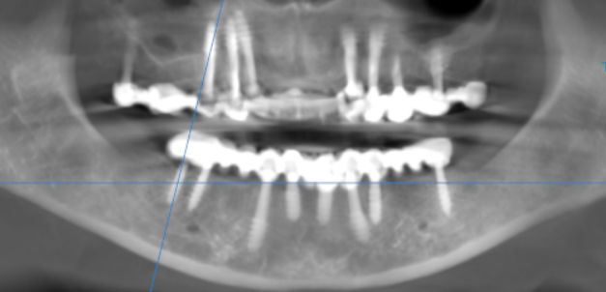
RECONSTRUCTED PANORAMIC VIEW

RIGHT MAXILLARY SINUS

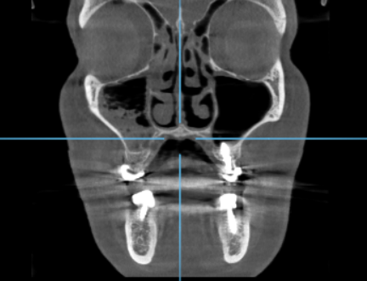

3-DIMENSIONAL VIEW

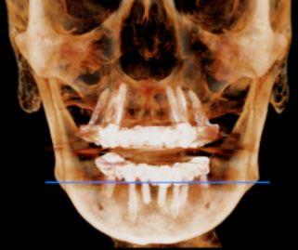

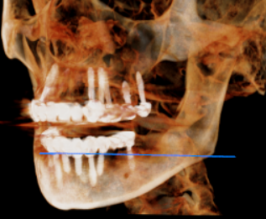
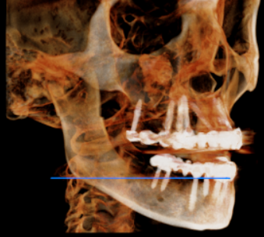

CROSS SECTIONAL VIEW
13 region | 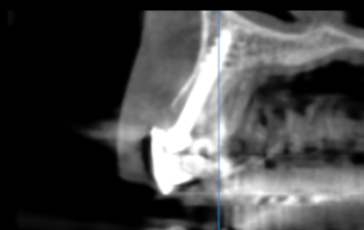
14 region | 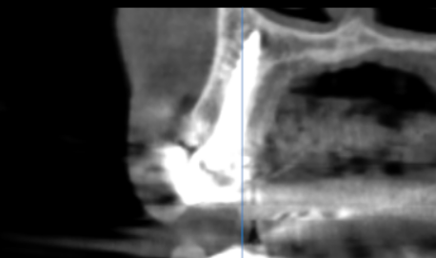
15 region | 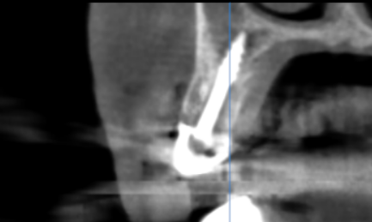
17 region | 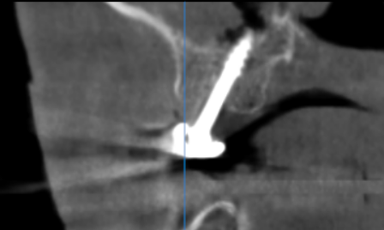
23 region | 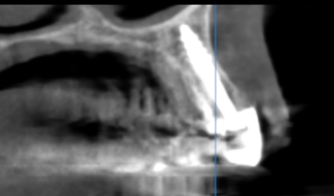
24 region | 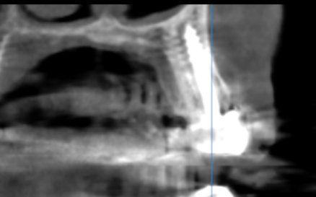
25 region | 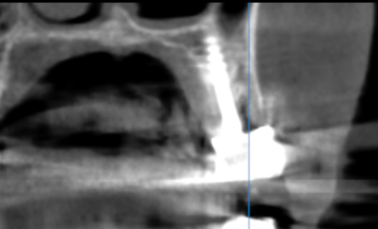
27 region | 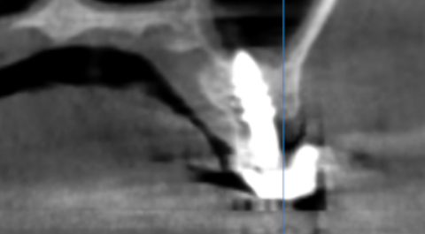
28 region | 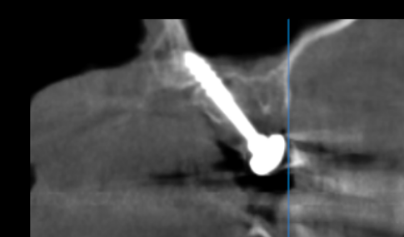
31 region | 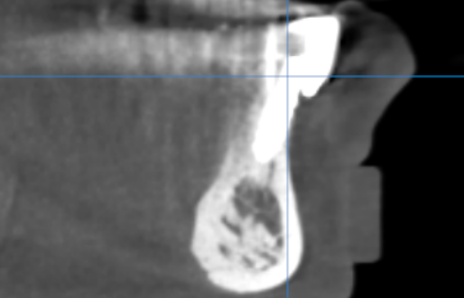
33 region | 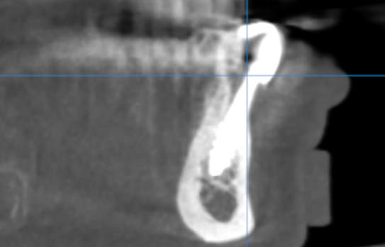
34 region | 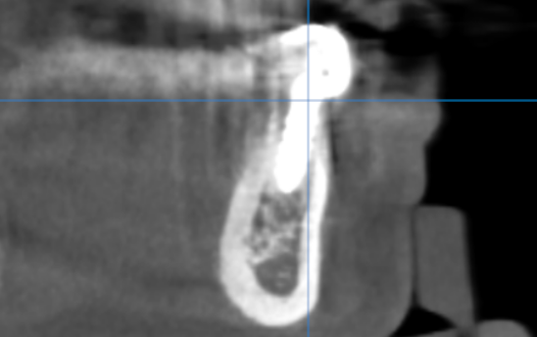
36 region | 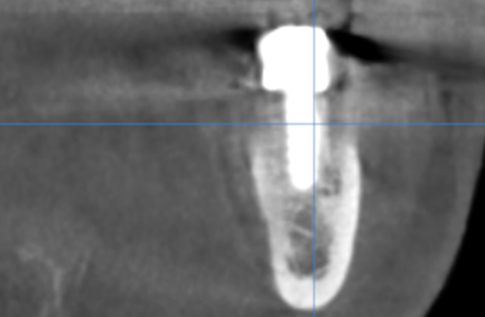
42 region | 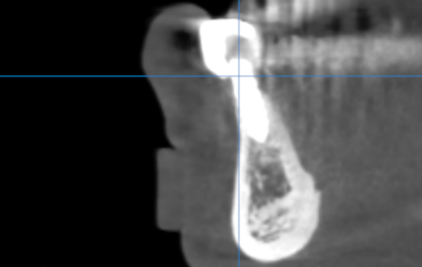
43 region | 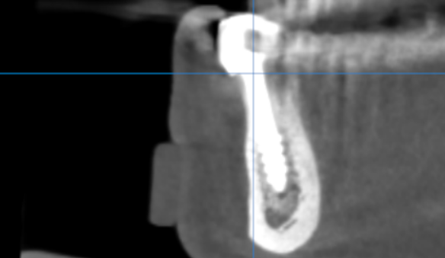
45 region | 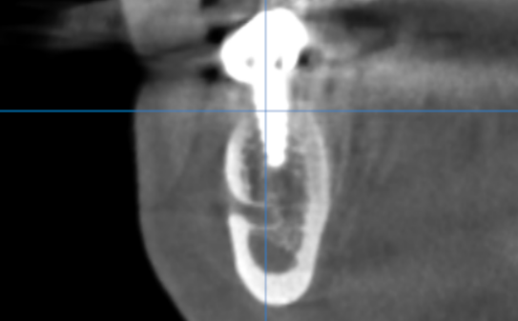
46 region | 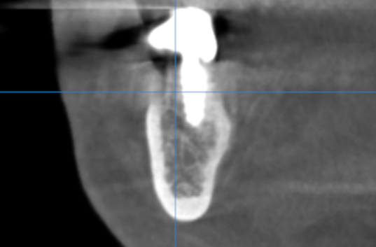

**** End of report ****

